Shopaa

Use-Case Specification

Version <1.0>

Revision History

| **Date** | **Version** | **Description** | **Author** |
| --- | --- | --- | --- |
| 8/11/2022 | 1.0 | Change use case names in Use case model | Nguyễn Thanh Phong |
|  |  |  |  |
|  |  |  |  |
|  |  |  |  |

Table of Contents

**1. Use-case Model** **4**

**2. Use-case Specifications** **4**

2.1 Use-case: Sign up 4

2.2 Use-case: Sign in 5

2.3 Use-case: Edit information 6

2.4 Use-case: Change password 7

2.5 Use-case: Charge display name 8

2.6 Use-case: Add to card 9

2.7 Use-case: Order foods 9

2.8 Use-case: Order information 10

2.9 Use-case: Register to be a seller 10

2.10 Use-case: Admin approve registration form 11

2.11 Use-case: Administrator delete comment, post 11

2.12 Use-case: Administrator delete account 12

2.13 Use-case: Report post 13

2.14 Use-case: Activity log 13

2.15 Use-case: Register sell another food 14

2.16 Use-case: Edit selling post 15

2.17 Use-case: Search 15

2.18 Use-case: Voucher 16

2.19 Use-case: Instruction 16

2.20 Use-case: Delivery management 17

2.21 Use-case: Notification 17

# Use-case Model

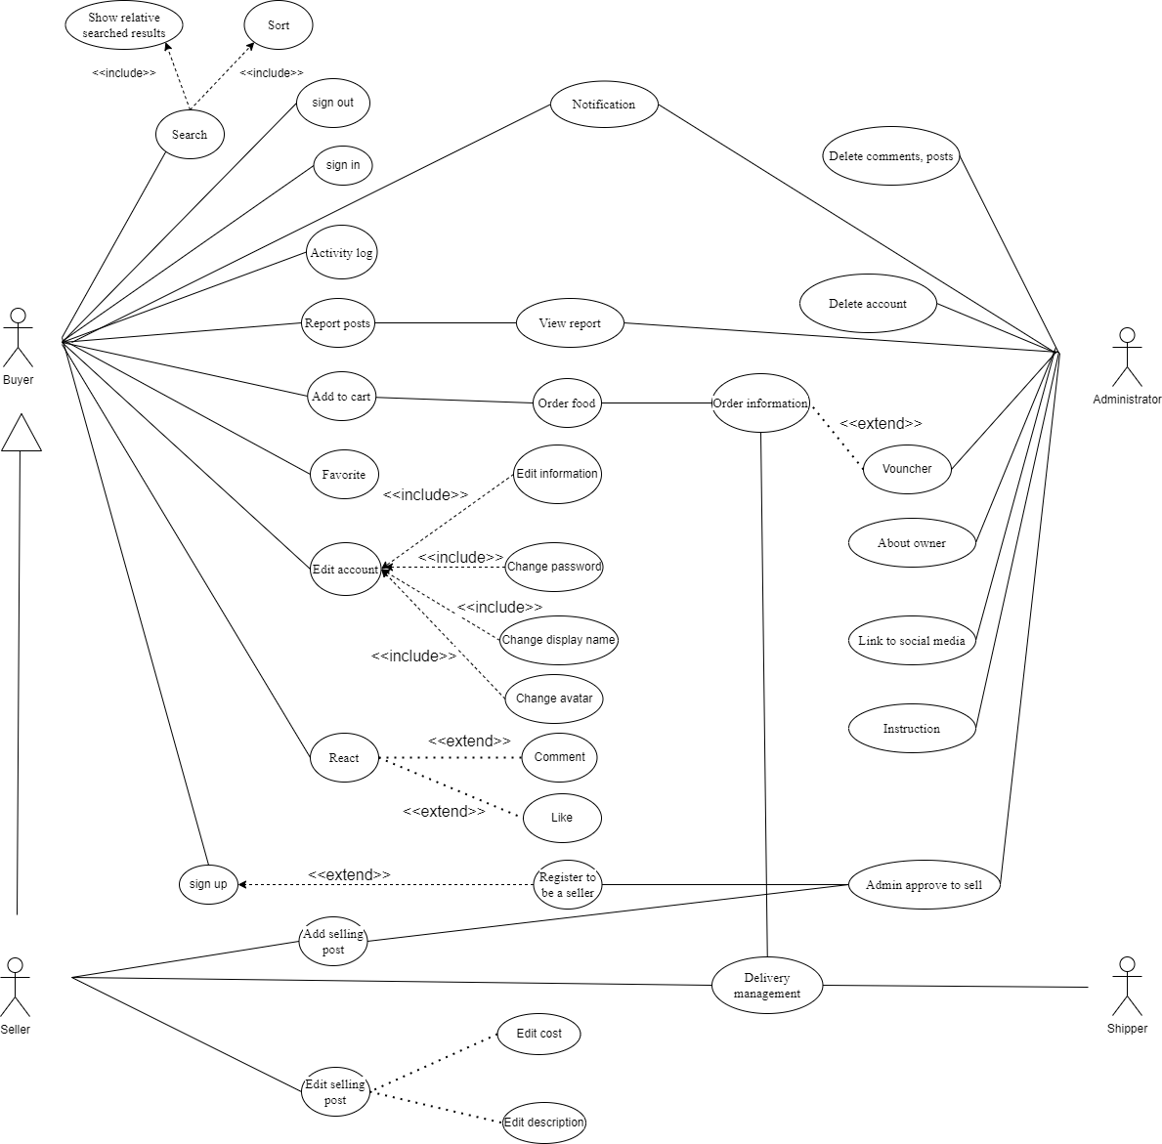

# Use-case Specifications

## Use-case: Sign up

| Use case name | Sign up |
| --- | --- |
| Brief description | This use case describes how the user create a new account |
| Actor | Buyer, Seller |
| Basis flow | 1. At the homepage, the user clicks the “Sign up” button. 2. System display the “Sign up” interface 3. User enter display name, username, password, re-enter password (password is a combination of at least six numbers, letters) 4. User click the “Sign up” button at this page 5. System check sign up information 6. System notice that “successful registration”, back to homepage |
| Alternative Flows | Alternative flow 1: If one of three fields is blank   1. if it is missing “username”, the system will notice that “Please enter your username”. 2. if it is missing “password”, the system will notice that “Please enter your password”. 3. if it is missing “username”, the system will notice that “Please re-enter your password ”.   Alternative flow 2: If the username already exists   1. if the username is already set by someone before, the system will notice that “Username already exists”.   Alternative flow 3: If the entered password is incorrect syntax   1. if the password is less than six characters, the system will notice that “Password must be more than six characters”. |
| Pre-conditions | User goes to homepage |
| Post-conditions | The user successfully creates a new account and can sign in. |

## Use-case: Sign in

| Use case name | Sign in |
| --- | --- |
| Brief description | This use case describes how to sign in to the system. Therefore react in post, order food and if you are seller, you can post product to sell on system |
| Actor | Buyer, Seller |
| Basis flow | 1. At the homepage, the user clicks the “Sign in” button 2. System display the “Sign in” interface 3. User enter username, password 4. After that, user click “Sign in” in page 5. System check if it’s account available 6. System notice that “Successful”, back to the homepage |
| Alternative Flows | Alternative flow 1:   1. In #4, user can press Enter instead of click “Sign in” button   Alternative flow 2: Sign in unsuccessful   1. In #5, if the account isn’t exist in the system, system will notice the “Wrong username or password” 2. The system will move to sign in page for user to input again   Alternative flow 3: Avoid spamming password   1. In #5 and #6, if the user fails to sign in more 4 times, the systems will show captcha to avoid spamming password to hack this account   Alternative flow 4: username or password (or both) is empty   1. System will notice “Please fill in” |
| Pre-conditions | User must have an account in the system |
| Post-conditions | The user successfully signs in and can order, react in any post, register to be a seller, and receive notification from the administrator. If you are the seller, you can post product to sell |

## Use-case: Edit information

| Use case name | Edit information |
| --- | --- |
| Brief description | This use case describes how to edit information in your account, you can update your information, email, phone number,.. |
| Actor | Buyer, Seller |
| Basis flow | 1. Sign in succesfully to the system 2. In the homepage, user click the avatar of this account 3. The system will show list of account’s features, that include edit information, change password, change avatar, change display name 4. User click “Edit information” 5. System show the edit information page 6. User input information, that need to update or change 7. User click “Complete” to complete 8. System notice “Edit information successfully” and update information of this account |
| Alternative Flows | Alternative flow 1:   1. In #7, user can press Enter instead of click “Complete” button   Alternative flow 2: Unique information   1. In #6, user inputs the same email, phone number as another account,.. so the system notice that “email/phone number already exist please type another one”   Alternative flow 3: Suddenly disconnect   1. In #6, If the user suddenly disconnect from the website, the information won’t change and keep the old version |
| Pre-conditions | User must sign in successfully to the website |
| Post-conditions | User’s information is updated base on what user inputs in change information page |

## Use-case: Change password

| Use case name | Change password |
| --- | --- |
| Brief description | This use case describes how to change the password of your account, protect your account |
| Actor | Buyer, Seller |
| Basis flow | 1. Sign in successfully to the system 2. In the homepage, user click the avatar of this account 3. The system will show list of account’s features, that include edit information, change password, change avatar, change display name 4. User click “Change password” 5. System show the change password page 6. User input new password, re-password, old password (password is a combination of at least six numbers, letters) 7. User click “Complete” to complete 8. System notice “Password changed” and update new password of this account 9. System log out account which is active and turn back to Sign in page |
| Alternative Flows | Alternative flow 1: Enter wrong current password   1. In #6, if the user input the old password doesn’t match with the current password, the system will notice the “Wrong password” and let the user type again. 2. If the user fail greater than 5 times, the system will block this feature and send email to identify verification   Alternative flow 2:   1. In #6, if the user input new password match with the old password or doesn’t match with re-password 2. System will notice “Error” and let the user enter input again   Alternative flow 3:   1. if the other device which is active on this system, the system will show a box to notice that “This account has changed. Please sign in again” |
| Pre-conditions | User must sign in successfully to the website |
| Post-conditions | Update user’s password based on what user inputs in the change password page. System will log out the account which is active in the system and let the user sign in again. |

## Use-case: Charge display name

| Use case name | Change display name |
| --- | --- |
| Brief description | This use case describes how to change the display name of your account, make unique name |
| Actor | Buyer, Seller |
| Basis flow | 1. Sign in successfully to the system 2. In the homepage, user click the avatar of this account 3. The system will show list of account’s features, that include edit information, change password, change avatar, change display name 4. User click “Display name” 5. System show the change display name page 6. User input new display name 7. User click “Complete” to complete 8. System notice “Display name complete ” and update new display name of this account |
| Alternative Flows | Alternative flow 1: display name is empty   1. System will notice “Please fill in” |
| Pre-conditions | User must sign in successfully to the website |
| Post-conditions | Update display name based on what user inputs in the display name page. |

## Use-case: Add to card

| Use case Name | Add a product to cart. |
| --- | --- |
| Brief description | This use case describes how the Buyer can buy a product |
| Actors | Buyer, Seller |
| Basic Flow | 1. At the homepage, the user enters keywords on the ‘Search’ field 2. Users clicks on ‘Search’ button to start searching a product 3. System displays the products found 4. User clicks ‘Add to cart’ button on the expected product 5. System adds a new product to cart 6. System displays the quantity of all products in the cart to the user |
| Alternative Flows | Alternative flow 1: User cannot find products searched   1. From #1 of the basic flow, user enters another term 2. Continue step #2 in the basic flow     Alternative flow 2: Shopping cart has already had the product   1. From #5 of the basic flow, system increases the quantity of the product 2. Continue step #6   Alternative flow 3: … |
| Pre-conditions | User goes to homepage and must sign in successfully |
| Post-conditions | The user successfully adds a new item to the cart or increases the quantity of the existing item in the cart. |

## 

## Use-case: Order foods

| Use case Name | Order foods in cart |
| --- | --- |
| Brief description | This use case describes how the Buyer can order a food. |
| Actors | Buyer, Seller |
| Basic Flow | 1. At the cart, Users click on the “Order” button to order food in the cart. 2. System displays a screen of the products in the cart, buyer information, buyer phone number, and a frame to apply the voucher(voucher’s frame can be empty). 3. After the user checks the information, users click on the “Order” button on this screen to buy food. 4. System will ask the users that “Are you sure with your choice ?”( Yes/No) 5. Users click “Yes” after making sure that all information is correct. 6. System notice that “Order successful” and change to “Order information” page |
| Alternative Flows | Alternative flow 1: If a user sees something wrong in information or wants to change an item in a cart.   1. After #4, user can click “No” at #4 if they want to cancel this order form. |
| Pre-conditions | User have an item in cart |
| Post-conditions | The user successfully buy food in cart |

## 

## Use-case: Order information

| Use case Name | Order information |
| --- | --- |
| Brief description | This use case describes how the Buyer checks the option about food they order and notice for the shipper. |
| Actors | Buyer, Seller |
| Basic Flow | 1. After user complete order food, the system will display bill information 2. User check the information and click to “Payment” 3. System will update user’s order to shipper |
| Alternative Flows | Alternative flow 1:   1. In #1, User can disconnect from the website, the bill information will be deleted |
| Pre-conditions | User must do order food before |
| Post-conditions | The user check and complete the bill, the shipper will receive it |

## Use-case: Register to be a seller

| Use case name | Buyer register to be a seller |
| --- | --- |
| Brief description | This use case allows a Buyer update to seller |
| Actor | Buyer |
| Basis flow | 1. At homepage buyer click the avatar of this account 2. System shows register button 3. Buyer click the button 4. System shows the form for buyer to fill 5. After buyer fill it, buyer click the submit button 6. System send registration to “Registration List” box 7. System will send notification if the registration is applied 8. Store will be added on the system 9. Account type change to Buyer |
| Alternative Flows | Alternative flow 1:  In #7, if the admin refuses the registration, System sends the refusal notification and does not do #8 #9. |
| Pre-conditions | Buyer must sign in successfully |
| Post-conditions | Seller have more function |

## Use-case: Admin approve registration form

| Use case name | Administrator approve registration |
| --- | --- |
| Brief description | This use case allows an Administrator approve registration |
| Actor | Administrator |
| Basis flow | 1. An administrator signs in to their account 2. Admin can view the “Registration List” box 3. After clicking, Admin view a list of the Registration 4. Admin click a Registration in the list 5. System show the form filled by user 6. Choosing the “Accept” button to accept a Registration 7. System will send notification to user 8. System add/update store on database |
| Alternative Flows | Alternative flow 1:  In #6, if the administrator chooses the “Deny” button, the Registration will be deleted. System sends the refusal notification and does not do #8 |
| Pre-conditions | Administrator must sign in successfully |
| Post-conditions | the selling post will be added/updated or not base on admin |

## Use-case: Administrator delete comment, post

| Use case name | Administrator deletes the reported comment,post |
| --- | --- |
| Brief description | This use case allows an administrator to delete a reported comment |
| Actor | Administrator |
| Basis flow | 1. An administrator signs in to their account 2. They can view the “Report List” box 3. After clicking, they view a list of the comments reported by the user 4. Admin click a Report in the list 5. System show the Report sent by user and the comment,post 6. Choosing the “Delete” button to delete a comment, post 7. System send notification to the user |
| Alternative Flows | Alternative flow 1:  In #4, if the administrator chooses the “Deny” button, the reported comment will not be eliminated  Alternative flow 2:  If the comment or post be deleted before being reviewed by administrator, report will be deleted |
| Pre-conditions | Administrator must sign in successfully |
| Post-conditions | The reported comment,post will be deleted or kept based on if it violates our conditions and national laws or not |

## Use-case: Administrator delete account

| Use case name | Administrator deletes suspect account |
| --- | --- |
| Brief description | This use case allows an administrator to deletes suspect account |
| Actor | Administrator |
| Basis flow | 1. An administrator signs in to their account 2. They can view the “Report Account List” box 3. After clicking, they view a list of the accounts reported by the use 4. Admin click a Report in the list 5. System show the suspect account and the report 6. Choosing the “Delete”button to delete an account 7. Send notification to the suspect user time before completely deleted 8. System will delete the Report after suspect user be deleted |
| Alternative Flows | Alternative flow 1:  In #4, if the administrator chooses the “Deny” button, the reported account will not be delete |
| Pre-conditions | Administrator must sign in successfully. Have a report |
| Post-conditions | The reported account will be deleted or kept based on if it violates our conditions and national laws |

## Use-case: Report post

| Use case name | User report a suspect post |
| --- | --- |
| Brief description | This use case allows to report a post which is not suitable to appear on the website |
| Actor | Buyer, seller |
| Basis flow | 1. User click the Report button at the store or comment want to report 2. System will show the form that has reason, violate which rule,...etc 3. User fill the form 4. User click Send button 5. System will send form to “Report list” box for admin to review |
| Alternative Flows | Alternative flow 1:   1. In #4, if the user exits, the form will be deleted. |
| Pre-conditions | Buyer, seller must sign in successfully. Find the store, comment want to report |
| Post-conditions | The reported store, comment will be deleted or kept based on admin |

## Use-case: Activity log

| Use case name | Activity log |
| --- | --- |
| Brief description | This use case allows the user can check history which they bought |
| Actor | Seller, Buyer |
| Basis flow | 1. At the homepage, user click the avatar of the account 2. System show the activity log button 3. User click the activity log button 4. System show the history page 5. The user can scroll down to see more older activity 6. The user select more detail 7. System will notice “See activity” or “Delete activity” |
| Alternative Flows | Alternative flow 1:   1. In #2, if the user don’t have any activity 2. The system will notice “Empty”   Alternative flow 2:   1. In #7, if the user click “See activity” 2. The system show detailly the activity   Alternative flow 3:   1. In #7, if the user click “Delete activity” 2. The system will delete activity from database |
| Pre-conditions | Users must sign in successfully. |
| Post-conditions | The activity history will be recorded |

## Use-case: Register sell another food

| Use case name | Seller register to sell another food |
| --- | --- |
| Brief description | This use case allows a Seller register to sell another food |
| Actor | Seller |
| Basis flow | 1. At homepage click the avatar of this account 2. System shows register button 3. Seller click the button 4. System shows the form for Seller to fill 5. After Seller fill it, Seller click the submit button 6. System sends registration to “Registration List” box 7. System will send notification if the registration is applied 8. Store will be added on the system 9. Account type change to Seller |
| Alternative Flows | Alternative flow 1:  In #6, if the admin refuses the registration, System sends the refusal notification and does not do #8 #9. |
| Pre-conditions | Seller must sign in successfully |
| Post-conditions |  |

## Use-case: Edit selling post

| Use case name | Edit selling post |
| --- | --- |
| Brief description | This use case allows Seller change cost and edit description about food |
| Actor | Seller |
| Basis flow | 1. Seller click the selling post 2. The system will display the selling post and in this will have button edit selling post on the right top 3. Seller click the button 4. System send the selling post which the seller can edit in it 5. After edit, Seller click the submit button 6. System notice “Changed” and update the selling post |
| Alternative Flows | Alternative flow 1:   1. In #4, if the user disconnect when they edit, the system will save the old version |
| Pre-conditions | Seller must sign in successfully and had the selling post |
| Post-conditions | The selling post will update base on what the seller input |

## Use-case: Search

| Use case name | Search |
| --- | --- |
| Brief description | Find a food that they want to buy |
| Actor | Buyer, seller |
| Basis flow | 1. At homepage system shows a list of icons of food 2. Users click the food icon that they want to eat 3. System shows store list that sell the food 4. Users click the searching bar 5. Users type a name of the store 6. Users click a find icon(magnifying glass icon) button to find 7. System display a result about store that have same name |
| Alternative Flows | Alternative flow 1: If the user doesn't type anything in the search box   1. The system will still find the item but with “ ” information 2. System show store base on default sorted list   Alternative flow 2: If the user finds the item it doesn't exist   1. The system will display the empty screen |
| Pre-conditions | User goes to the homepage. |
| Post-conditions | Users find out what they need. |

## Use-case: Voucher

| Use case name | Voucher |
| --- | --- |
| Brief description | Administrator will create voucher and the user will use it to buy discount |
| Actor | Buyer, Seller, Shipper, Administrator |
| Basis flow | 1. After the user complete fill in order information, the user input voucher which receive from Administrator 2. System will check the voucher 3. System notice “Voucher available” and discount the bill 4. User click “Complete” button to complete order |
| Alternative Flows | Alternative flow 1:The voucher not available   1. In #2, if the voucher not available 2. System notice “Not available” |
| Pre-conditions | User must have available voucher |
| Post-conditions | The bill will discount base on the voucher |

## 

## Use-case: Instruction

| Use case name | Instruction |
| --- | --- |
| Brief description | Guide for new user use the website |
| Actor | Buyer, Seller |
| Basis flow | 1. User go to the homepage and click to “Instruction” button 2. System display the instruction page 3. The instruction is written by administrator |
| Alternative Flows |  |
| Pre-conditions | User goes to homepage |
| Post-conditions | User will know how to use the features |

## 

## Use-case: Delivery management

| Use case name | Delivery management |
| --- | --- |
| Brief description | Seller, buyer and shipper can see the order information |
| Actor | Buyer, Seller, Shipper |
| Basis flow | 1. At homepage, Buyer, Seller click the avatar icon 2. System shows Delivery button 3. Buyer, Seller click the button 4. System display the delivery management page 5. System show the bill and delivery progress 6. System will send notification went the order is delivered |
| Alternative Flows | Alternative flow 1: No order   1. System will notice “No order”   Alternative flow 2: Can’t deliver   1. In #5, if the shipper can’t deliver for some reason. They note the reason 2. System send reason to Buyer, Seller through notification |
| Pre-conditions | User must sign in, and have the order |
| Post-conditions |  |

## 

## Use-case: Notification

| Use case name | Notification |
| --- | --- |
| Brief description | Users will be sent a notification |
| Actor | Buyer, Seller |
| Basis flow | 1. In the homepage, user can click the bell icon to check Notification 2. System shows the notification page 3. System shows the list of notification 4. User can click any notification to check 5. System shows the notification that user click |
| Alternative Flows | Alternative flow 1: No notification   1. System will notice “No notification” |
| Pre-conditions | User must sign in successfully |
| Post-conditions |  |